Special Educational Needs and Disabilities (SEND) Information Report
New Ash Green Primary School



Inclusion Team
SEND Governor:
Hannah Ward
Inclusion Lead:
Mrs Sam Goss
Contact No. 01474 873858
office@new-ash.kent.sch.uk

Approved by: | Mrs Caroline Cain, Executive Headteacher | Date: September 2026
Last reviewed on: | September 2026
Next review due by: | October 2027

Contents
1. What types of SEND does the school provide for? 4
2. Which staff will support my child? 5
3. What should I do if I think my child has SEND? 7
4. What happens if the school identifies a need? 8
5. How will the school measure my child’s progress? 9
6. How will I be involved in decisions made about my child’s education? 10
7. How will my child be involved in decisions made about their education? 11
8. How will the school adapt its teaching for my child? 122
9. How will the school evaluate whether the support in place is helping my child? 143
10. How will the school ensure my child has appropriate resources? 143
11. How will the school make sure my child is included in activities alongside pupils who don’t have SEND? 144
12. How does the school make sure the admissions process is fair for pupils with SEN or a disability? 155
13. How does the school support pupils with disabilities? 165
14. How will the school support my child’s mental health and emotional and social development? 166
15. What support is in place for looked-after and previously looked-after children with SEN? 176
16. What support will be available for my child as they transition between classes or settings or in preparing for adulthood? 17
17. What support is available for me and my family? (Local Offer) 188
18. What should I do if I have a complaint about my child’s SEND support? 19
19. Supporting Documents…………………………………………………………………………………………………………….19
20. Glossary 20

Dear parents and carers,
The aim of this Information Report is to explain how we implement our SEND policy. In other words, we want to show you how SEND support works in our school.
If you would like to know more about our arrangements for SEND, read our SEND policy alongside this Information Report.
You can find it on our website https://www.new-ash.kent.sch.uk/our-school/sen/
Note: If there are any terms we have used in this information report that you are unsure of, please use the Glossary at the end of the report.
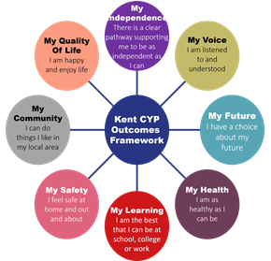
As educational professionals, we are all working towards the ultimate goal of growing independent young people as they prepare for adulthood. All provision and support we provide is working towards achieving the Kent Children and Young People (CYP) Outcomes Framework:

1. What types of SEND does the school provide for?
Our school provides for pupils with the following needs (as outlined in the SEND Code of Practice 2015):

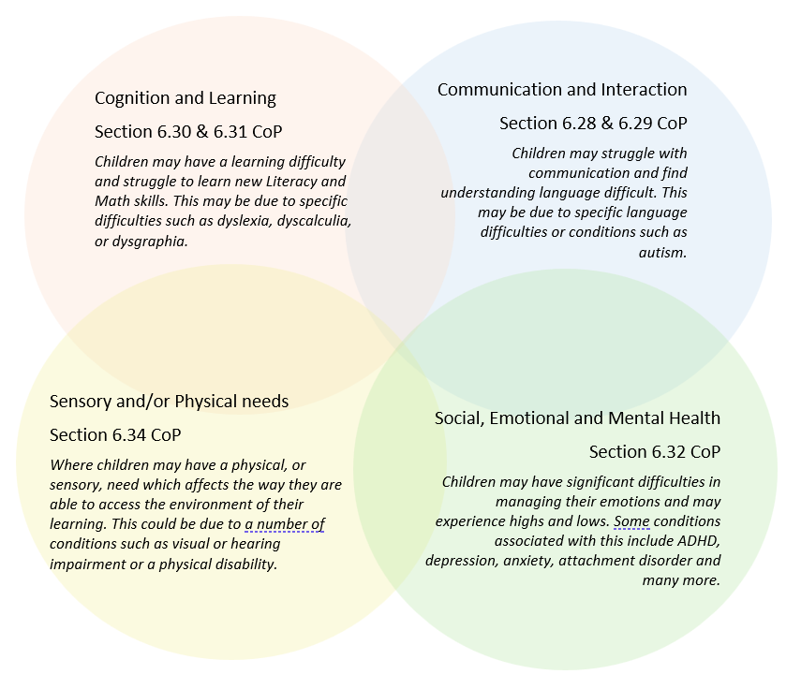

Often you will find that children’s needs overlap and are rarely confined to one area of need, which is why it is important to gain a wholistic overview of your child.
More information about the Areas of Need can be found in the Special educational needs and disability code of practice: 0 to 25 years (link below).
SEND_Code_of_Practice_January_2015.pdf (publishing.service.gov.uk)


2. Which staff will support my child, and what are their key responsibilities?

At New Ash Green Primary School all staff are considered responsible for supporting the needs of pupils with SEND. Our staff are committed to regular, high-quality training to ensure that they have the knowledge and skills to better meet a wide range of pupil needs.
Below outlines key staff who will be supporting your child. Please note that this list is not exhaustive.

Our Special Educational Needs Co-ordinator, or SENCO
Our SENCO is Sam Goss.
She has experience in this role and has worked in this role for 5 years. Sam is a qualified teacher, having taught in primary schools for over 20 years.
She achieved a Postgraduate Certificate in SEN Coordination with National Award for Special Educational Needs Coordination in 2022.
Sam works four days a week to lead SEND provision across the whole school.

Class/subject teachers
All of our teachers receive in-house SEND training and are supported by the SENCO to meet the needs of pupils who have SEND.
Over the last 12 months all staff have had further training in Autism Awareness and Playfulness, Acceptance, Curiosity and Empathy (PACE), Precision Teaching and Developmental Language Disorder (DLD).
Class teams have also accessed training that is relevant to the needs of the children in their class.

Teaching assistants (TAs)
We have a team of 22 TAs, which includes 7 higher-level teaching assistants (HLTAs) / Cover Supervisors who are trained to deliver SEN provision.
We have a number of TAs who are trained to deliver interventions such as Sensory Circuits, Beam, Speech and Language, Phonics, Precision Teaching and Social Skills.
In the last academic year, TAs have had further training in Autism Awareness and Playfulness, Acceptance, Curiosity and Empathy (PACE), Precision Teaching and Developmental Language Disorder (DLD).
External agencies
Sometimes we need extra help to offer our pupils the support that they need. Whenever necessary we will work with external support services to meet the needs of our pupils with SEND and to support their families. A discussion would take place with parents and carers prior to this being accessed with a request, where necessary, for parental consent. These may include:

- Speech and language therapists
- Educational psychologists
- Community of Schools
- Specialist Teaching and Learning Service
- GPs or paediatricians
- School nurses
- SEND Inclusion Advisor
- Children and Young People’s Mental Health Service (CYPMHS)
- Education welfare officers
- NELFT practitioners
- Occupational therapists
- Therapeutic practitioners
- Safeguarding services



- Voluntary sector organisation

3. What should I do if I think my child has SEND?

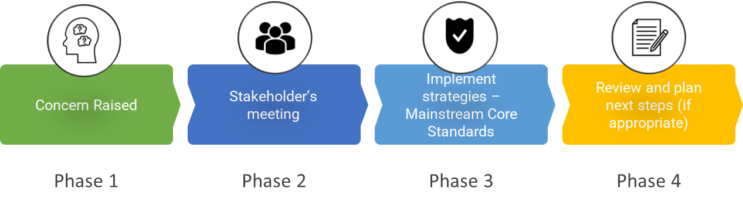

Phase 1 | If you think your child might have SEN, the first person you should speak to is your child’s teacher.  Parents can contact your child’s class teacher by emailing the school office or at the end of the day when they collect their child.  They will pass the message on to our Inclusion Manger who will be in touch to discuss your concerns.  The Inclusion Manager, Mrs Sam Goss, is contactable via the school office at office@new-ash.kent.sch.uk or 01474 873858.
Phase 2 | We will meet with you to discuss your concerns and try to get a better understanding of what your child’s strengths and difficulties are. Together we will decide what outcomes to seek for your child and agree on next steps. We will make a note of what’s been discussed and add this to your child’s record.
Phase 3 | We will implement the agreed strategies and monitor these over an agreed period of time. These are likely to be universal strategies set out in the mainstream core standards. A copy of this can be found here: https://www.kelsi.org.uk/__data/assets/pdf_file/0005/117257/Special-educational-needs-mainstream-core-standards-guide-for-parents.pdf . This will initiate the ‘Graduated Approach’ where support will be continually reviewed. See next page for more details.
Phase 4 | If we decide that your child needs SEND support, we will formally notify you in writing and your child will be added to the school’s SEND register. They will receive additional support and this will be reviewed using the assess, plan, do, review model.

4. What happens if the school identifies a need?
Getting to know every individual child, through fostering a positive relationship, is central to our approach at New Ash Green Primary School. All our teachers are aware of SEND and ‘watch and monitor’ any pupils who may not be making the expected levels of progress academically and/or socially. This might include Reading, Writing, Maths, attention and focus and social communication.
If the teacher notices that a pupil is having difficulties, they try to find out if the pupil has any gaps in their learning. If they can find a gap, the school will provide appropriate support. Pupils who don’t have SEND usually make progress quickly once the gap in their learning has been filled.
If the pupil is still finding it difficult to make the expected progress, the teacher will talk to the SENCO and will contact you to discuss the possibility that your child has SEND, and the school will follow the graduated approach (see previous page).

At New Ash Green Primary School, we monitor the progress of all pupils six times a year to review their academic progress and attainment. We use national assessments with all pupils at key points: baseline assessments on entry, phonics screening at the end of year 1 and statutory SATs testing at end of Key Stage 2. Teacher assessments which determine end of Key Stage data are rigorously monitored via school and cluster moderation. We also have a range of assessment tools available in school to help identify and clarify the needs of pupils. These include Speech Link and Language Link, the Dyslexia Portfolio, Phonics Assessments, BPVS (British Picture Vocabulary Score), YARC (York Assessment of Reading Comprehension), GL Single Word Reading Test, and Language for Learning.
Where progress is not sufficient, even if a special educational need has not been identified, and after discussion with parents, we put in place extra support to enable the pupil to catch up or to address any emotional or social difficulties. Examples of extra support are differentiated tasks, speech and language programmes, phonics programmes, literacy and maths interventions, personalised reading programmes, interventions to support fine and gross motor skills, social skills, Lego Therapy, Draw & Talk, ELSA (Emotional Literacy Support) and professional counselling.
Some pupils may continue to make inadequate progress, despite high-quality teaching targeted at their areas of weakness. For these pupils, and in consultation with parents, we will firstly use a range of assessment tools in school to help determine the underlying difficulties. We also have access to external advisors and specialists which can be discussed with the Community of Schools process, Specialist Learning and Teaching Service and Educational Psychology. We can make or support referrals to Occupational Therapy, Speech and Language Therapy or Community Paediatricians, when we can evidence the difficulties and strategies that have been tried in school.
The purpose of this more detailed assessment is to understand what additional resources and different approaches are required to enable the pupil to make improved progress. These will be shared with parents, recorded on a provision map and reviewed regularly, and refined / revised as necessary. At this point we will have identified that the pupil has a special educational need because the school is making special educational provision for the pupil which is additional to and different from what is normally available. The pupil will be added to the school’s SEND Register after discussion with parents and formally notified by letter.
If the pupil is making good progress using this additional and different resource (but would not be able to maintain this good progress without it) we will continue to identify the pupil as having a special educational need. If the pupil maintains good progress without the additional and different resources, he or she will not be identified with special educational needs. When there is a change in a pupil’s SEND status, parents will be formally notified by letter.
We will ensure that all teachers and support staff who work with pupils are aware of the support to be provided and the teaching approaches to be used.
The same process is followed if a concern is raised by the school.

5. How will the school measure my child’s progress?
We will follow the ‘graduated approach’ to meeting your child’s SEND needs.
The graduated approach is a 4-part cycle of assess, plan, do, review.
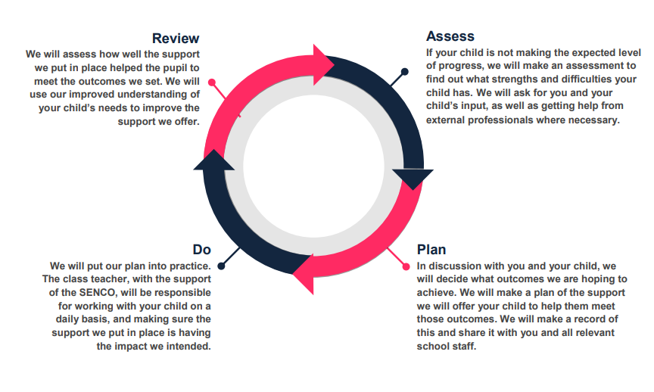
As a part of the planning stage of the graduated approach, we will set outcomes that we want to see your child achieve.
Whenever we run an intervention with your child, we will assess them before the intervention begins. This is known as a ‘baseline assessment’. We do this so we can see how much impact the intervention has on your child’s progress.
We will track your child’s progress towards the outcomes we set over time and improve our offer as we learn what your child responds to best. Interventions are reviewed each seasonal term (approximately 12 weeks).
This process will be continual. If the review shows a pupil has made progress, they may no longer need the additional provision made through SEN support. For others, the cycle will continue, and the school's targets, strategies and provisions will be revisited and refined.

6. How will I be involved in decisions made about my child’s education?
We will provide an annual report on your child's progress.
Your child’s class teacher will meet you 3 times a year to:
- Set clear outcomes for your child’s progress
- Review progress towards those outcomes
- Discuss the support we will put in place to help your child make that progress
- Identify what we will do, what we will ask you to do, and what we will ask your child to do
The SENCO may also attend these meetings to provide extra support.
We know that you’re the expert when it comes to your child’s needs and aspirations. So, we want to make sure you have a full understanding of how we’re trying to meet your child’s needs, so that you can provide insight into what you think would work best for your child.
We also want to hear from you as much as possible so that we can build a better picture of how the SEND support we are providing is impacting your child outside of school.
If your child’s needs or aspirations change at any time, please let us know right away so we can keep our provision as relevant as possible.
Please provide the school with copies of any medical reports.
After any discussion we will make a record of any outcomes, actions and support that have been agreed. This record will be shared with all relevant staff.
If you have concerns that arise between these meetings, please contact your child’s class teacher by emailing the school office or at the end of the day when you collect your child.

7. How will my child be involved in decisions made about their education?
The level of involvement will depend on your child’s age and individual needs. We recognise that no two pupils are the same, so we will decide on a case-by-case basis, with your input.
We may seek your child’s views by asking them to:
- Attend meetings to discuss their progress and outcomes
- Prepare a presentation, written statement, video, drawing, etc.
- Discuss their views with a member of staff who can act as a representative during the meeting
- Complete a survey

8. How will the school adapt its teaching for my child?
The school’s Special Educational Needs and Disability policy and Accessibility Plan are both available on the school website. https://www.new-ash.kent.sch.uk/our-school/policies/
Your child’s teacher is responsible and accountable for the progress and development of all the pupils in their class.
High-quality teaching is our first step in responding to your child’s needs. We will make sure that your child has access to a broad and balanced curriculum in every year they are at our school.
We will adapt our approaches to how we teach to suit the way the pupil works best. There is no 'one size fits all’ approach to adapting the curriculum, we work on a case-by case basis to make sure the adaptations we make are meaningful to your child and are guided by the Mainstream Core Standards in the first instance.

These adaptations may include:
- Adapting our approaches, for example, giving longer processing times, pre-teaching of key vocabulary, reading instructions aloud, etc.
- Adapting our resources and staffing
- Using recommended aids, such as laptops, coloured overlays, visual timetables, larger font, etc.
- Teaching assistants or support staff will support pupils appropriately depending on their presentation of need
- Scaffolding lesson materials

We may also provide the following interventions:

Dimension of Need | Intervention
Communication and Interaction   | Speech and Language (following specific, individual advice from Speech and Language Therapist)  Speech Link  Language Link  Talk About  Language for Thinking  Language for Behaviour and Emotions  EAL Support  Lego Therapy  Social Stories  TEACCH Approach (now/next)  Intensive Interaction  Attention Autism
Cognition and Learning   | Specific Reading Schemes  Phonological Awareness  Sound Linkage  Word Shark  Dynamo Maths  Precision Teaching  Toe by Toe  Hornet  Better Reading Partnership  Acceleread/Accelewrite
Social, Emotional and Mental Health   | Additional check in’s with class team  Listening Ear with Learning Mentor  Emotional Literacy Support (ELSA)  Draw and Talk  Therapy Dog session  Play Therapy with Accredited Counsellor  HERO Club - Here Every day, Ready On time.
Physical and Sensory   | BEAM  Clever Fingers  Sensory Circuits  Sensory room sessions  Handwriting Booster

These interventions are part of our contribution to Kent County Council’s local offer.

9. How will the school evaluate whether the support in place is helping my child?
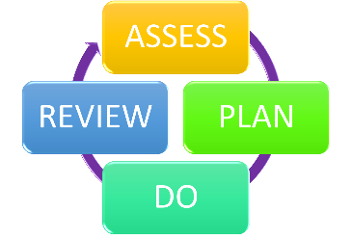
We will evaluate the effectiveness of provision for your child by:
- Reviewing their progress towards their goals each term
- Reviewing the impact of interventions after 12 weeks
- Using pupil questionnaires
- Monitoring by the SENCO
- Using provision maps to measure progress
- Holding an annual review (if they have an education, health and care (EHC) plan)

10. How will the school ensure my child has appropriate resources?
It may be that your child’s needs mean we need to provide additional resources such as:
- Additional resources to support their learning
- Adaptations to in class support
- Further training for our staff
- External specialist expertise
Where appropriate, we will consult with external agencies to get recommendations on what will best help your child access their learning and use our best endeavours to ensure these are supplied.

11. How will the school make sure my child is included in activities alongside pupils who don’t have SEND?


The expectation is that all schools provide an inclusive provision for all pupils. It may be necessary for some pupils to receive interventions in addition to a broad and balanced curriculum.
All our extra-curricular activities and school visits are available to all our pupils, including our before and after-school clubs.
All pupils are encouraged to go on our school trips, including our residential trips.
All pupils are encouraged to take part in sports day, school plays and performances and special workshops.
No pupil is ever excluded from taking part in these activities because of their SEN or disability and we will make whatever reasonable adjustments are needed to make sure that they can be included.

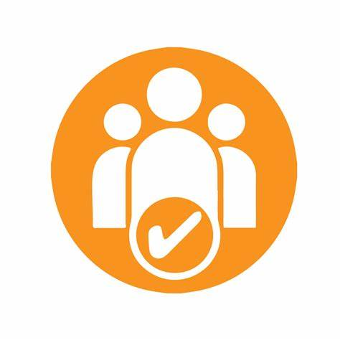
12. How does the school make sure the admissions process is fair for pupils with SEN or a disability?

New Ash Green Primary School does not discriminate against prospective pupils with a disability or with SEN. Our Admissions Policy sets this out clearly. The oversubscription criteria is followed to avoid unfairly disadvantaging prospective pupils with a disability or special educational needs. The school’s Admission Policy is available on the school website: https://www.new-ash.kent.sch.uk/our-school/policies/
Any child with a Statement of Special Educational Needs (SSEN) or Education, Health and Care Plan (EHCP) naming New Ash Green Primary School will be admitted. As a result of this, the published admissions number will be reduced accordingly before places are allocated to other pupils. A Statement of Special Educational Need is a statement made by the Local Authority under section 324 of the Education Act 1996 specifying the special educational provision required for that child. An Education, Health and Care Plan is a plan made by the Local Authority under section 37 of the Children and Families Act 2014 specifying the special education provision required for that child.
A transition process is in place to support pupils transitioning into New Ash Green Primary School. This may be at the start of reception or as part of fair access in year transitions.
This will include where possible and appropriate:
- Planned transition meeting involving parents, child and previous pre-school / school and SENCo/SLT to plan transition support and collect relevant background information, including previous support.
- Visual transition booklet.
- Transition sessions prior to starting.
- Opportunities to meet with their new class teacher and see the school.
- For some pupils with complex needs a gradual transition may be beneficial. This will be time
limited and planned and agreed by parents and where necessary the LEA.

13. How does the school support pupils with disabilities?


New Ash Green Primary school is a single-storey school. Alternative routes with ramps are available for the few spaces with stairs. There is an Aqua Suite containing a disabled toilet, shower and mobile hoist.
Additional auxiliary aids will be acquired, as needed, via LEA and medical services. Reasonable adaptations to the curriculum and the setting are made to ensure that pupils with disabilities have full access to a broad and balanced curriculum in line with their peers. The school’s Accessibility Plan can be found on the school’s website: https://www.new-ash.kent.sch.uk/our-school/policies/
To note, under the Equality Act 2010 you are termed disabled if you have a physical or mental impairment that has a ‘substantial’ and ‘long-term’ negative effect on your ability to do normal daily activities.

14. How will the school support my child’s mental health and emotional and social development?
We provide support for pupils to progress in their emotional and social development in the following ways:
- Pupils with SEND are encouraged to be part of the school council.
- Pupils with SEND are also encouraged to be part of lunchtime / after school clubs to promote teamwork/building friendships.
- We provide extra pastoral support for listening to the views of pupils with SEND through daily check in’s with the class team and then, where appropriate, needs driven extra support (e.g., Additional 1:1 check in’s with an adult from the class team, Listening Ear with the Learning Mentor, further therapeutic support (see SEMH interventions list). We use a range of approaches to capture pupil voice including pupil questionnaires, pupil voice, support from the Learning Mentor and Play Therapist, using the signs of safety (houses) approach.
- We run a breakfast-based intervention called HERO Club (Here Every day Ready On time) to support children who may find the transition from home to school challenging and need extra support with social or emotional development.
- We have a ‘zero tolerance’ approach to bullying. We prevent bullying in the school by always listening to our pupils, encouraging pupils to tell staff about their concerns, encouraging pupils not to be by-standers. Acting on any incidents and ensuring that they are fully recorded on CPOMs and reported to parents and LEA where appropriate. Awareness of bullying is discussed as part PHSE curriculum and in assemblies.

15. What support is in place for looked-after and previously looked-after children with SEND?


Sarah McCann is the Designated Teacher for looked-after children and previously looked-after children. Sarah will work with Sam Goss our SENCO, to make sure that all teachers understand how a looked-after or previously looked-after pupil’s circumstances and their SEND might interact, and what the implications are for teaching and learning.
Pupils who are looked-after or previously looked-after will be supported much in the same way as any other child who has SEND. However, looked-after pupils will also have a personal education plan (PEP). We will make sure that the PEP and any SEND support plans or EHC plans are consistent and complement one another.

16. What support will be available for my child as they transition between classes or settings or in preparing for adulthood?
Between years

To help pupils with SEND be prepared for a new school year we:
- Ask both the current teacher and the next year’s teacher to attend final meeting of the year when the pupil’s SEND is discussed, and a handover of information is completed.
- Schedule lessons with the incoming teacher towards the end of the summer term as well as needs driven visits to the new playground, coat peg areas, toilets to support the familiarisation and transition process.
- Visual transition booklets
- Social stories
Between schools
When your child is moving on from our school, we will ask you and your child what information you want us to share with the new setting. Please note that schools have a legal duty to share any safeguarding concerns or history with new schools.
Between phases
The SENCO of the secondary school will meet with our SENCO. They will discuss the needs of all the pupils who are receiving SEND support.
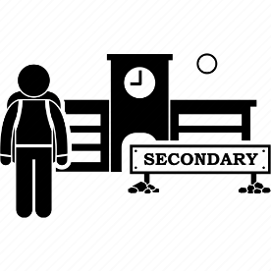
Pupils will be prepared for the transition by:
- Practising with a secondary school timetable
- Learning how to get organised independently
- Plugging any gaps in knowledge
- Participation in additional transition support
- Transition booklets
- Transition days at their secondary schools

17. What support is available for me and my family?
If you have questions about SEND, or are struggling to cope, please get in touch to let us know. We want to support you, your child and your family.
To see what support is available to you locally, have a look at Kent’s Local Offer. Kent publishes information about the local offer on their website: https://local.kent.gov.uk/kb5/kent/directory/results.action?localofferchannel=0

Our local special educational needs and disabilities information advice and support service (SENDIASS) organisations are:
Information, Advice and Support Kent (IASK) - Kent County Council: https://www.kent.gov.uk/education-and-children/special-educational-needs/listening-to-your-voice-and-taking-action/Information-Advice-and-Support-Kent
Special Educational Needs and/or Disabilities (SEND) Information Hub – KELSI: https://www.kelsi.org.uk/special-education-needs/send-information-hub
Kent Parents and Carers Together (PACT) - Kent County Council: https://www.kent.gov.uk/education-and-children/special-educational-needs/listening-to-your-voice-and-taking-action/kent-pact

Local charities that offer information and support to families of pupils with SEND are:
We Are Beams – Supporting Disabled Children and Young People: https://wearebeams.org.uk/
SNAAP – Special Needs Advisory & Activities Project in Kent: https://www.snaap.org.uk/
Kent Autistic Trust: https://www.kentautistictrust.org/

Other organisations can be found on the Kent SEND Information Hub website: https://www.kelsi.org.uk/special-education-needs/send-information-hub

National charities that offer information and support to families of pupils with SEND are:
- IPSEA
- SEND family support
- NSPCC
- Family Action
- Special Needs Jungle

18. What should I do if I have a complaint about my child’s SEND support?
The school’s Complaints Policy can be found on the school website: https://www.new-ash.kent.sch.uk/our-school/policies/
Complaints about SEND provision in our school should be made to the Inclusion Manger (SENCo) in the first instance. They will then be referred to the school’s complaints policy.
If you are not satisfied with the school’s response, you can escalate the complaint. In some circumstances, this right also applies to the pupil themselves.
To see a full explanation of suitable avenues for complaint, see pages 246 and 247 of the SEND Code of Practice.
If you feel that our school discriminated against your child because of their SEND, you have the right to make a discrimination claim to the first-tier SEND tribunal. To find out how to make such a claim, you should visit: https://www.gov.uk/complain-about-school/disability-discrimination
You can make a claim about alleged discrimination regarding:
- Admission
- Exclusion
- Provision of education and associated services
- Making reasonable adjustments, including the provision of auxiliary aids and services
Before going to a SEND tribunal, you can go through processes called disagreement resolution or mediation, where you try to resolve your disagreement before it reaches the tribunal.
Information about resolution and mediation can be found at:
Mediation and Resolution: https://www.kelsi.org.uk/special-education-needs/special-educational-needs/mediation-and-resolution
SEND Information Hub: https://www.kelsi.org.uk/special-education-needs/send-information-hub

19. Supporting documents
The following policies can be found on the school website: https://www.new-ash.kent.sch.uk/our-school/policies/


- Equality Policy
- Child Protection and Safeguarding Policy
- Behaviour Policy
- Accessibility Plan
- Attendance Policy
- Primary Admissions Policy
- SEND policy
- Teaching and Learning Policy
- Whole School Graduated Provision

Additional documents can be accessed from the following websites:

- SEN & Disabilities Code Of Practice 2015: https://www.gov.uk/government/publications/send-code-of-practice-0-to-25
- Mainstream Core Standards: https://www.kelsi.org.uk/__data/assets/pdf_file/0005/117257/Special-educational-needs-mainstream-core-standards-guide-for-parents.pdf

20. Glossary
- Access arrangements – special arrangements to allow pupils with SEND to access assessments or exams
- Annual review – an annual meeting to review the provision in a pupil’s EHC plan
- Area of need – the 4 areas of need describe different types of needs a pupil with SEND can have. The 4 areas are communication and interaction; cognition and learning; physical and/or sensory; and social, emotional and mental health needs.
- CAMHS – child and adolescent mental health services
- Differentiation – when teachers adapt how they teach in response to a pupil’s needs
- EHC needs assessment – the needs assessment is the first step on the way to securing an EHC plan. The local authority will do an assessment to decide whether a child needs an EHC plan.
- EHC plan – an education, health and care plan is a legally-binding document that sets out a child’s needs and the provision that will be put in place to meet their needs.
- First-tier tribunal/SEND tribunal – a court where you can appeal against the local authority’s decisions about EHC needs assessments or plans and against discrimination by a school or local authority due to SEND
- Graduated approach – an approach to providing SEND support in which the school provides support in successive cycles of assessing the pupil’s needs, planning the provision, implementing the plan, and reviewing the impact of the action on the pupil
- Intervention – a short-term, targeted approach to teaching a pupil with a specific outcome in mind
- Local offer – information provided by the local authority which explains what services and support are on offer for pupils with SEND in the local area
- Outcome – target for improvement for pupils with SEND. These targets don't necessarily have to be related to academic attainment
- Reasonable adjustments – changes that the school must make to remove or reduce any disadvantages caused by a child’s disability
- SENCO – the special educational needs co-ordinator
- SEN – special educational needs
- SEND – special educational needs and disabilities
- SEND Code of Practice – the statutory guidance that schools must follow to support pupils with SEND
- SEND information report – a report that schools must publish on their website, that explains how the school supports pupils with SEND
- SEND support – special educational provision which meets the needs of pupils with SEND
- Transition – when a pupil moves between years, phases, schools or institutions or life stages

